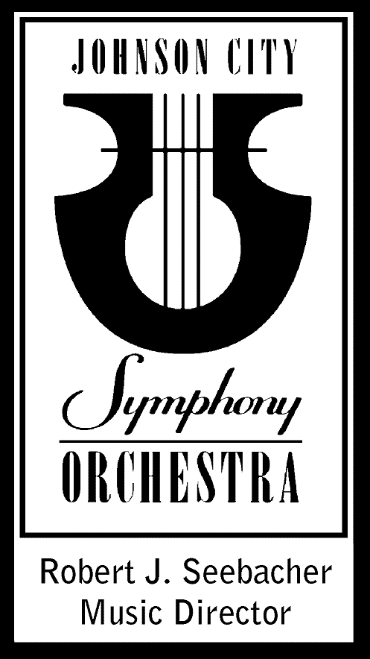
2018-2019 Season
Audition Announcement

Second Trumpet

Thursday, September 6, 2018 OR Wednesday, September 5, 2018
Beginning at 6:00 p.m. Beginning at 5:00 PM
Seeger Chapel Haslam Music Center
Milligan College University of Tennessee
Elizabethton, TN Knoxville, TN

Audition Requirements:

1. Solo of applicant’s choice. (No more than 3 minutes.)

2. Excerpts

Trumpet (all Trumpet I parts):
Beethoven: Fidelio Overture No. 3 – Offstage Fanfare
Brahms: Academic Festival Overture – mm. 63-92
Dvorak: Symphony No. 8 – Movement IV, Beginning to measure 18
R. Strauss: Death and Transfiguration – 11 measures after Rehearsal “Y” to Rehearsal “Z”
Stravinsky: Petrushka – Ballerina’s Dance (1 measure before Rehearsal “69” to Rehearsal “70)
Tchaikovsky: Symphony No. 4 – Movement I, mm. 7 to Rehearsal “A”

Excerpts are available at www.imslp.org or www.brassexcerpts.com.

Audition Contact:
Evan Edwards, Personnel Manager
Cell phone: (423) 367-9621
E-mail: personnelmanager@jcsymphony.com

PLEASE CALL TO SET UP AN AUDITION APPOINTMENT.

Please note: Audition scores and/or audition panel comments will not be shared with the applicant. Thank you for your interest in the Johnson City Symphony Orchestra.
Johnson City Symphony Orchestra PO Box 533 Johnson City, TN 37605
Phone (423) 926-8742 www.jcsymphony.com

The Johnson City Symphony Orchestra is an equal opportunity employer.

